Test the mobile phone

iPhone 6

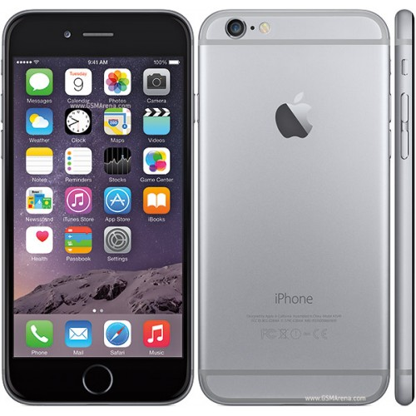

**Beta testing**

Turn on the phone

**Validation**

Unlock with password

Unlock with Touch ID

Call test

Camera test

Battery test

**Verification**

Maximum CPU power

Comparison of the design between the description in the test plan and the final result

Functional operating system IOS 11

**Security testing**

An attempt to unlock the phone without entering a password

An attempt to unlock the phone with an incorrect password entry

An attempt to unlock the phone with someone else's fingerprint

An attempt to unlock the phone through an external program is connected to the computer

**Negative testing**

When communicating on the phone to release the phone to concrete

Checking the immersion of devices under water

**Stress testing**

To prove endurance of the case throwing the phone from 1 meter

To prove endurance of the case throwing the phone from 2 meters.

To prove endurance of the body density by lowering the phone half the water.

To prove endurance of the density of the case, lowering it into the sand.

To prove endurance of the body density by lowering the phone in the snow.

Exhaust the battery.

Documentation testing.

**UI Testing**

What color

What shape

Interface design

**Entry Point Testing**

New

Used

**Black Box testing**

We work intuitively

**Functional Testing**

Checking whether it works

Does the phone display all the indicators correctly

**Usability testing**

Швидкий запуск

Швидке відблокування

Comfortable and quick menu

Opening speeds: Safari, Facebook

**Compatibility testing**

Can be a charge of unauthorized chargers brands

Use - every day

For sports, business, daily affairs

**Perfomence testing**

What is the battery life?

How many times can be repaired

Term of use

**Component testing**

We have a mobile device

We have a charger

**Integration testing**

Does it work with a charger